[10:-10] (array([-26.84190577, 28.32286767]), array([[ 0.04523872, -0.06699097],

[-0.06699097, 0.09924166]])) 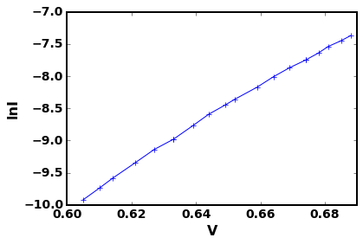

[11:-10] (array([-26.81756789, 28.28695864]), array([[ 0.04522602, -0.06696208],

[-0.06696208, 0.09918357]])) 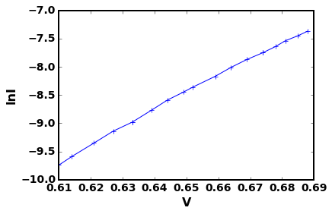

[12:-10] (array([-26.79490693, 28.25351925]), array([[ 0.04623744, -0.06845331],

[-0.06845331, 0.10138247]])) 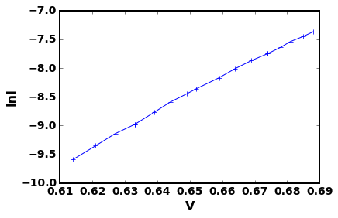

[13:-10] (array([-26.76293771, 28.20635435]), array([[ 0.04693894, -0.06950229],

[-0.06950229, 0.10295086]])) 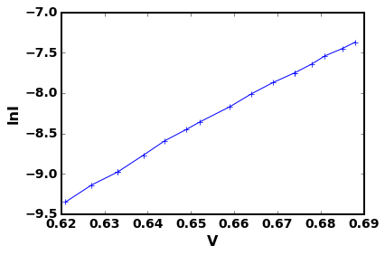

[14:-10] (array([-26.70298535, 28.11796971]), array([[ 0.04679589, -0.06927284],

[-0.06927284, 0.10258336]])) 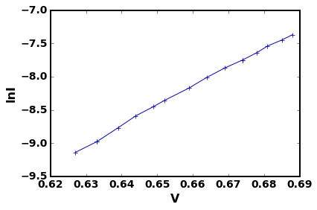

[15:-10] (array([-26.65468481, 28.04680521]), array([[ 0.04973214, -0.07359999],

[-0.07359999, 0.10896038]])) 